|  |  |  |
| --- | --- | --- |
|  | **MEENAKSHI SUNDARARAJAN ENGINEERING COLLEGE**  **Kodambakkam, Chennai-600024** |  |

**NM1042 – MERN STACK POWERED BY MONGODB**

**DEPARTMENT OF COMPUTER SCIENCE AND ENGINEERING**

**PROJECT TITLE: ONLINE COMPLAINT REGISTRATION AND MANAGEMENT SYSTEM USING MERN STACK**

|  |  |
| --- | --- |
| **TEAM ID:** | **NM2024TMID20182** |
| **FACULTY MENTOR:** | **Mrs. M. Sowmiya** |

**Project submitted by,**

|  |  |  |
| --- | --- | --- |
| **NAAN MUDHALVAN ID** | **NAME** | **REGISTER NUMBER** |
| 1599535CAE0370CB7374F14C3F67BD15 | *Selvakumar P* | *311521104052* |
| B3703FB63677D5987D341046EA53C6D3 | *Abbhinandan G* | *311521104001* |
| 1E79CFECAE9CD05B1D7474AF6507F4A7 | *Aswin H* | *311521104303* |
| 16E0BD19F76E9368B964BE79ACF01EF8 | *Prasanth S* | *311521104305* |

ANNA UNIVERSITY: CHENNAI 600 025

**BONAFIDE CERTIFICATE**

Certified that this project report “**ONLINE COMPLAINT REGISTRATION AND MANAGEMENT SYSTEM USING MERN STACK**” is the bonafide work of “**Selvakumar P (311521104052), Abbhinandan G (311521104001), Aswin H (311521104303), Prasanth S (311521104305)”** Naan Mudhalvan Team ID “**NM2024TMID20182**” who carried out the project work under my supervision.

**SIGNATURE SIGNATURE**

Mrs. M. Sowmiya, M.E. Dr.S.Aarthi,M.E., Ph.D.

**ASSISTANT PROFESSOR HEAD OF THE DEPARTMENT**

Computer Science and Engineering

Meenakshi Sundararajan Engineering College

No. 363, Arcot Road, Kodambakkam, Chennai -600024

Computer Science and Engineering

Meenakshi Sundararajan Engineering College

No. 363, Arcot Road, Kodambakkam, Chennai -600024

Submitted for the project viva voce of Bachelor of Engineering in Computer Science and Engineering held on ________________.

# INTERNAL EXAMINER EXTERNAL EXAMINER

**ACKNOWLEDGEMENT**

First and foremost, we express our sincere gratitude to our Respected Correspondent **Dr. K. S. Lakshmi**, our beloved Secretary **Mr. N. Sreekanth**, Principal **Dr. S. V. Saravanan** for their constant encouragement, which has been our motivation to strive towards excellence.

Our primary and sincere thanks goes to **Dr. S. Aarthi,** Head of the Department, Department of Computer Science and Engineering, for her profound inspiration, kind cooperation and guidance.

We are grateful to **Mrs. M. Sowmiya**, Internal Guide, Assistant Professor as our project coordinator for their invaluable support in completing our project. We are extremely thankful and indebted for sharing expertise, and sincere and valuable guidance and encouragement extended to us.

Above all, we extend our thanks to God Almighty without whose grace and blessings it would not have been possible.

# ABSTRACT

The **Online Complaint Registration and Management System** is a digital platform designed to simplify and streamline the process of managing customer complaints. By enabling users to submit, track, and resolve complaints online, the system eliminates the need for traditional, manual complaint handling methods. Users can easily register on the platform, submit complaints with detailed descriptions, and track their progress through automated notifications and real-time updates. The system centralizes all complaints into one database, making it easier for administrators to monitor, prioritize, and assign complaints to the appropriate departments for resolution. This not only improves transparency but also ensures that no complaint is overlooked or lost in the system.

For administrators, the platform provides powerful management tools to categorize complaints, analyze trends, and generate detailed reports on complaint handling performance. The system helps to improve the overall efficiency of customer service operations by automating routine tasks and providing clear metrics on resolution times and user satisfaction. With its user-friendly interface and data-driven insights, the **Online Complaint Registration and Management System** enhances communication between customers and service providers, leading to faster problem resolution and higher customer satisfaction. This system offers a scalable, cost-effective solution for businesses and organizations looking to optimize their complaint management processes and deliver a higher level of service to their customers.

|  |  |  |
| --- | --- | --- |
|  | **TABLE OF CONTENTS** |  |
| **CHAPTER NO.** | **TITE** | **PAGE NO.** |
|  | **ABSTRACT** | iv |
|  | **LIST OF TABLES** | v |
|  | **LIST OF FIGURES** | vii |
|  | **LIST OF SYMBOLS, ABBREVIATIONS AND**  **EXPANSIONS** | viii |
| **1** | **INTRODUCTION** |  |
|  | 1. PROJECT TITLE | 1 |
|  | 1. TEAM MEMBERS | 1 |
| **2** | **ABOUT THE PROJECT** |  |
|  | 1. PROJECT OVERVIEW | 1 |
|  | 1. PURPOSE | 2 |
|  | 1. EXISTING SYSTEM | 3 |
|  | 1. PROBLEM STATEMENT | 3 |
| **3** | **SYSTEM ARCHITECTURE** |  |
|  | 3.1 SYSTEM ARCHITECTURE | 4 |
|  | 3.2 HARDWARE REQUIREMENTS | 5 |
|  | 3.3 SOFTWARE REQUIREMENTS | 7 |
| **4.** | **IDEATION** |  |
|  | 4.1 IDEATION & BRAINSTORMING | 9 |

|  |  |  |
| --- | --- | --- |
| **5.** | **REQUIREMENT ANALYSIS** |  |
|  | 5.1 FUNCTIONAL REQIREMENTS | 13 |
|  | 5.2 NON-FUNCTIONAL REQUIREMENTS | 15 |
| **6.** | **SYSTEM MODELLING** |  |
|  | 6.1 UNIFIED MODELLING LANGUAGE | 17 |
|  | 6.2 USE CASE DIAGRAM | 17 |
|  | 6.3 CLASS DIAGRAM | 18 |
|  | 6.4 SEQUENCE DIAGRAM | 19 |
|  | 6.5 ACTIVITY DIAGRAM | 20 |
|  | 6.6 STATE CHART DIAGRAM | 22 |
| **7.** | **SYSTEM IMPLEMENTATION** |  |
|  | 7.1 PROPOSED SYSTEM | 23 |
|  | 7.2 SOURCE CODE | 29 |
| **8.** | **PROJECT DESIGN** |  |
|  | 8.1 DATA FLOW DIAGRAM | 31 |
|  | 8.2 USER STORIES | 32 |
| **9.** | **ADVANTAGES AND DISADVANTAGES** | 35 |
| **10.** | **CONCLUSION AND FUTURE ENHANCEMENT** |  |
|  | 10.1 CONCLUSION | 38 |
|  | 10.2 FUTURE ENHANCEMENT | 39 |
| **11.** | **APPENDIX SCREENSHOT** | 41 |

|  |  |  |
| --- | --- | --- |
| **LIST OF TABLES** | | |
| **TABLE NO:** | **NAME OF THE TABLE** | **PAGE NO.** |
| 3.1 | SYSTEM ARCHITECTURE | 5 |
| 4.2 | BRAINSTORMING IDEAS | 11 |
| 5.1 | FUNCTIONAL REQUIREMENTS | 13 |
| 5.2 | NON-FUNCTIONAL REQUIREMENTS | 15 |

|  |  |  |
| --- | --- | --- |
| **LIST OF FIGURES** | | |
| **FIGURE NO.** | **NAME OF THE FIGURE** | **PAGE NO.** |
| 3.2 | HARDWARE REQUIREMENTS | 6 |
| 3.3 | SOFTWARE REQUIREMENTS | 8 |
| 4.1 | IDEATION & BRAINSTORMING | 10 |
| 6.2 | USE CASE DIAGRAM | 18 |
| 6.3 | CLASS DIAGRAM | 19 |
| 6.4 | SEQUENCE DIAGRAM | 20 |
| 6.5 | ACTIVITY DIAGRAM | 21 |
| 6.6 | STATE CHART DIAGRAM | 22 |

**LIST OF SYMBOLS, ABBREVIATIONS AND EXPANSION**

**ABBREVIATION EXPANSION**

SPA SINGLE-PAGE APPLICATION

UML Unified Modeling Language

NPM Node Package Manager

**CHAPTER 1**

**INTRODUCTION**

# PROJECT TITLE:

# Online Complaint Registration and Management System using MERN Stack

# TEAM MEMBERS:

# Selvakumar P - Project Coordinator

# Abbhinandhan G

# Aswin H

# Prasanth S

# CHAPTER 2

# ABOUT THE PROJECT

The **Online Complaint Registration and Management System** is a comprehensive digital solution aimed at modernizing how complaints are logged, tracked, and resolved. By automating critical processes, it ensures a smooth and efficient workflow for organizations while offering users a transparent and hassle-free experience. The project leverages advanced technology to address common pain points in traditional complaint handling methods, enhancing both user satisfaction and organizational efficiency.

This system serves as a centralized platform where complaints can be submitted, routed, tracked, and resolved effectively. With features like real-time updates, intelligent complaint routing, and user-agent communication, it brings convenience to users and operational excellence to organizations.

# PROJECT OVERVIEW

The **Online Complaint Registration and Management System** is designed to address the gaps in traditional complaint resolution methods. It allows users to register their complaints through an intuitive interface, provides real-time updates on the progress, and enables direct communication with support agents. For organizations, it offers a data-driven approach to monitor complaints, analyze trends, and identify areas for improvement.

This system replaces manual processes with a streamlined, automated workflow, ensuring that complaints are addressed promptly and appropriately. It reduces the time spent on resolving complaints and enhances accountability, making it an invaluable tool for organizations looking to improve service quality and customer relations.

The system's responsive design makes it accessible across multiple devices, allowing users to log and track complaints on the go. With robust security features, it ensures that sensitive information is protected, fostering trust among users.

# PURPOSE

The primary purpose of the **Online Complaint Registration and Management System** is to:

* Empower users with a simple, efficient way to submit and monitor complaints.
* Provide organizations with a structured framework for managing complaints efficiently.
* Reduce delays in complaint resolution by streamlining workflows and automating processes.
* Enhance transparency by keeping users informed at every stage of the resolution process.
* Foster trust between users and organizations by demonstrating a commitment to addressing concerns effectively.

# EXISTING SYSTEM

In the current scenario, many organizations rely on outdated methods for managing complaints, such as manual record-keeping, email-based communication, or over-the-phone submissions. These systems are often plagued by several issues:

* Lack of a centralized repository for complaints, leading to disorganized record management.
* Inability to track complaint statuses in real-time, resulting in user frustration.
* High response times due to inefficient workflows and manual intervention.
* Limited scope for analyzing complaint trends or generating actionable insights.

# PROBLEM STATEMENT

The inefficiencies in traditional complaint handling systems create significant challenges for both users and organizations:

1. **User Challenges**:

* Difficulty in registering complaints quickly and comprehensively.
* Lack of real-time updates on complaint status.
* Limited or no interaction with support agents to clarify issues.
* Frustration due to delayed responses and unresolved complaints.

1. **Organizational Challenges**:

* Lack of automation in complaint routing and resolution, leading to delays.
* Inefficient allocation of resources to handle complaints.
* Inability to monitor performance metrics such as resolution times or user satisfaction levels.
* Poor feedback collection and analysis, resulting in missed opportunities for service improvement.

The **Online Complaint Registration and Management System** aims to eliminate these pain points by introducing a unified platform that is efficient, transparent, and user-friendly. It addresses the root causes of user dissatisfaction and operational inefficiencies, ensuring that complaints are handled with the urgency and care they deserve.

**CHAPTER 3**

# SYSTEM ARCHITECTURE

# SYSTEM ARCHITECTURE

The **Online Complaint Registration and Management System** is structured as a three-layer architecture comprising the **Frontend**, **Backend**, and **Database** layers.

1. **Frontend**:
   * Built using **React**, employing a **component-based structure** to ensure modularity, maintainability, and scalability.
   * Implements **Single-Page Application (SPA)** for seamless user experience.
   * Real-time updates and responsiveness are achieved through tools like **Socket.IO**, **Material-UI**, and **Bootstrap**.
   * Integrates **RESTful APIs** for data communication and uses **Axios** for efficient API calls.
2. **Backend**:
   * Developed with **Node.js** and **Express.js** to support scalable and secure server-side operations.
   * Features a **modular structure** with controllers, services, and models for better code organization.
   * Implements **JWT-based authentication** and real-time communication with **Socket.IO**.
   * Centralized error handling, data validation (using **Joi**), and logging (using **Winston**) ensure robustness.
3. **Database**:
   * **MongoDB** is used for data storage, managed with **Mongoose** for schema validation and operations.
   * Collections such as **Users** and **Complaints** store data efficiently, with indexes optimized for frequent queries.
   * CRUD operations ensure seamless user registration, complaint submission, and status tracking.

**Table 1:** Database Schema collection

|  |  |  |  |
| --- | --- | --- | --- |
| **Collection** | **Field** | **Type** | **Description** |
| **Users** | Username | String | Unique identifier for each user |
| Email | String | Email address used for communication |
| Password | String(encrypted) | Hashed password for secure login |
| Role | String(user/admin/agent) | Role assigned to the user |
| **Complaints** | User | ObjectId (reference to User) | User who submitted the complaint |
| Title | String | Title of the complaint |
| Description | String | Detailed complaint information |
| Status | Enum (submitted/in-progress) | Current status of the complaint |

# HARDWARE REQUIREMENTS

To deploy the **Online Complaint Registration and Management System**, the following hardware requirements are recommended:

1. **Client-Side Requirements**:
   * Device: Desktop, Laptop, or Mobile
   * Processor: Minimum 2 GHz dual-core
   * RAM: Minimum 4 GB (8 GB recommended for optimal performance)
   * Storage: 200 MB free space for frontend caching and local storage
2. **Server-Side Requirements**:
   * Processor: Quad-core processor (Intel Xeon or AMD Ryzen series)
   * RAM: Minimum 8 GB (16 GB recommended for high traffic)
   * Storage: Minimum 500 GB SSD for fast read/write operations
   * Network: High-speed internet with a bandwidth of at least 10 Mbps

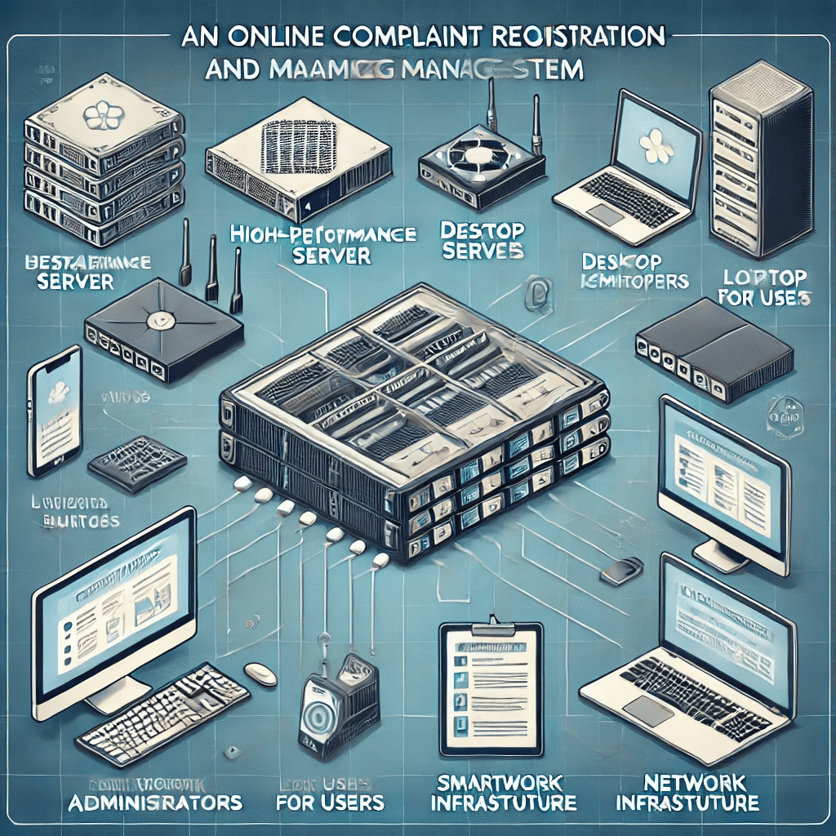

**Figure 1:** Essential Hardware Components for Online Complaint Registration  
 and Management System

# SOFTWARE REQUIREMENTS

The following software is necessary to build and operate the system:

1. **Frontend**:
   * Operating System: Windows, macOS, or Linux
   * Framework: React (Latest stable version)
   * Tools: Visual Studio Code, Node.js, NPM/Yarn
   * Libraries: Material-UI, Axios, Formik, React Router
2. **Backend**:
   * Operating System: Linux (Ubuntu preferred) or Windows Server
   * Runtime: Node.js (LTS version)
   * Framework: Express.js
   * Tools: Postman, Nodemon, PM2
3. **Database**:
   * MongoDB (Latest version)
   * Database Client: MongoDB Compass or Robo 3T
   * ODM Library: Mongoose
4. **Additional Software**:
   * Version Control: Git with GitHub or GitLab for repository management
   * Deployment: Docker (Optional), NGINX, or Apache
   * Security Tools: HTTPS setup with SSL/TLS, CSRF protection modules

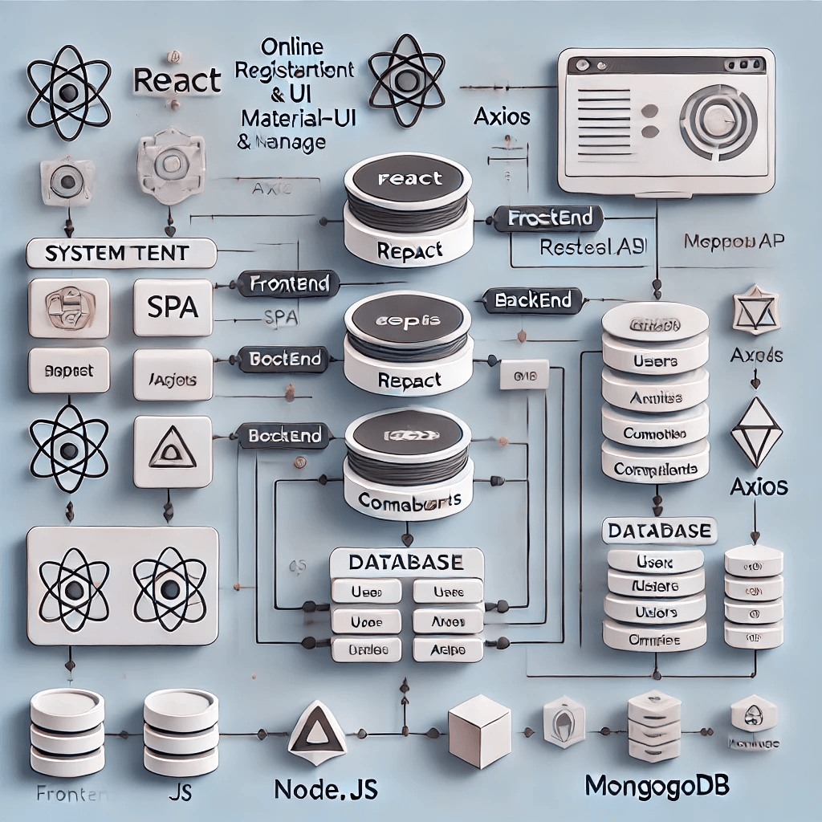

**Figure 2:** System Architecture of Online Complaint Registration and Management System

**CHAPTER 4**

**IDEATION**

# IDEATION & BRAINSTORMING

# The ideation and brainstorming phase of the Online Complaint Registration and Management System is crucial for defining the project’s scope, identifying key features, and envisioning the user experience. During this phase, the project team collaborates to generate ideas that will shape the system's functionality, ensuring it effectively meets user needs and expectations.

# Key Objectives:

# Simplifying User Experience: Create an intuitive interface for users to easily register and track complaints without encountering complexity.

# Real-Time Communication: Enable real-time updates for complaints, allowing users to track progress and interact with agents.

# Role-Based Access Control: Ensure different user roles (admin, agent, user) have appropriate access and permissions for different system features.

# Efficient Complaint Management: Develop mechanisms to assign complaints to agents, set priorities, and manage their status throughout resolution.

# Security & Data Integrity: Ensure sensitive information (e.g., complaint data, user credentials) is securely handled.

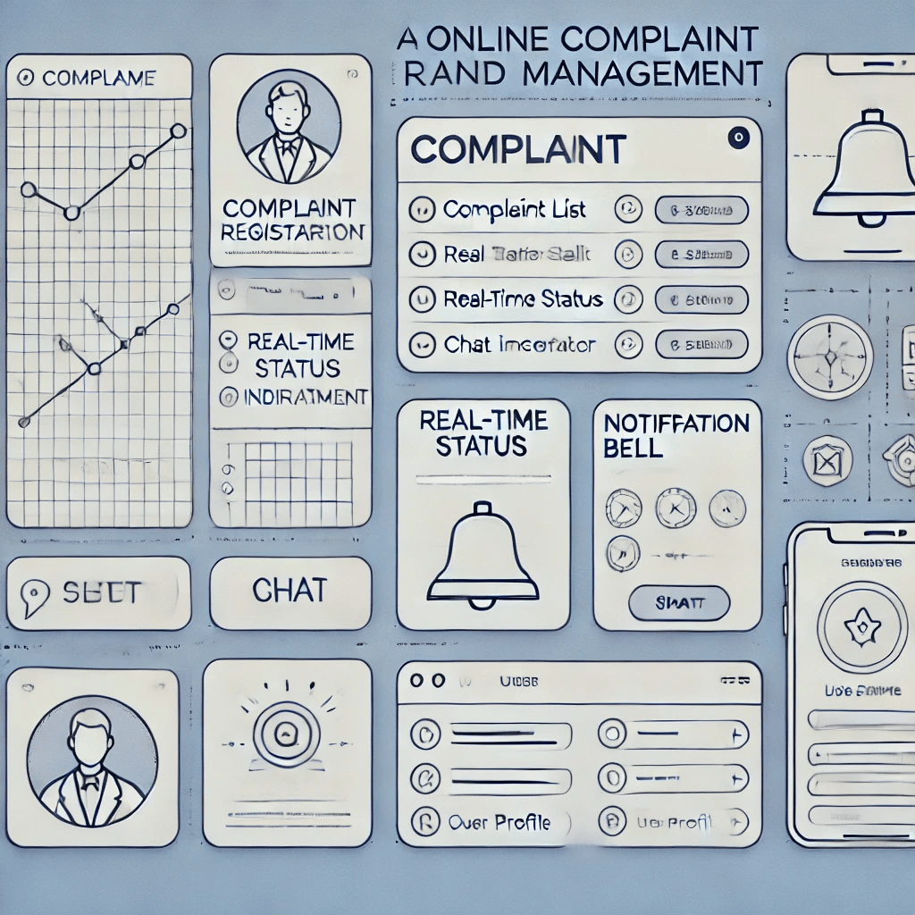

Figure 3: A Online Complaint Ideas and Brainstorming

# BRAINSTORMING IDEAS

# User Dashboard Design:

# Problem: Users may find it overwhelming to navigate complex systems.

# Idea: A clean, simple dashboard displaying user complaints, status updates, and priority-level filters.

# Complaint Categorization:

# Problem: Complaints could be categorized into numerous types, making it challenging for users to file them correctly.

# Idea: Provide an intuitive dropdown or search functionality for categorizing complaints based on their type.

# Notification System:

# Problem: Users need to be promptly informed of updates to their complaints.

# Idea: Use real-time notifications (via WebSockets) to inform users of complaint status changes, agent assignments, and resolution updates.

# Real-Time Chat System:

# Problem: Lack of direct communication between users and agents can delay resolution.

# Idea: Integrate a real-time chat feature using WebSockets to allow instant communication between users and agents.

# Automated Status Updates:

# Problem: Users may not know when their complaints are being reviewed or resolved.

# Idea: Automatically update complaint statuses as they move through different stages (e.g., "submitted," "in-progress," "resolved") and notify users in real time.

**Table 2:** Brainstorming Ideas for Features

|  |  |  |
| --- | --- | --- |
| Feature | Description | Benefit |
| User Dashboard | A simple interface to view complaints, statuses, and priorities. | Provides users with a quick overview of their complaints and statuses. |
| Complaint Categorization | A dropdown or search bar for categorizing complaints. | Helps users classify complaints easily, reducing errors in submission. |
| Real-Time Notifications | WebSocket integration for live updates on complaint statuses. | Keeps users informed of their complaint's progress without delay. |
| Real-Time Chat | A chat interface for user-agent communication. | Enables direct communication between users and agents, reducing response time. |
| Automated Status Updates | Status updates triggered automatically as complaints progress. | Ensures transparency and keeps users up-to-date on their complaints. |

**CHAPTER 5**

**REQUIREMENT ANALYSIS**

# FUNCTIONAL REQUIREMENTS

The functional requirements describe the specific features and functionalities the system must have. These are crucial for determining what the system should do, from the user interface to the database handling.

1. **User Registration and Authentication**

* **Description:** The system must allow users to register and log in securely.
* **Features:**
  + Users must provide personal details like name, contact information, and email to register.
  + A secure authentication mechanism must be implemented (e.g., email verification, password hashing).
  + Users can reset their passwords via email or SMS.

|  |  |
| --- | --- |
| **Feature** | **Description** |
| User Registration | Users can create an account by providing necessary details. |
| User login | Users must be able to log in using their registered credentials. |
| User Password | Users can reset their password in case they forget it. |

1. **Complaint Registration**

* **Description:** Users should be able to register complaints through an easy-to-use interface.
* **Features:**
  + Users can submit complaints with relevant details (e.g., title, description, category).
  + Attachments (such as screenshots or documents) must be allowed.
  + Users can categorize complaints (e.g., technical issues, customer service, billing).

|  |  |
| --- | --- |
| **Feature** | **Description** |
| Complaint Submission | Users can submit complaints with description and category. |
| Attachments | Users can attach relevant files to their complaints. |
| Complaint Categorization | Users can select a category for the complaint (e.g., technical, billing). |

1. **Complaint Tracking and Status Updates**

* **Description:** Users should be able to track the status of their complaints.
* **Features:**
* Users can check the status of their complaints (e.g., "Under Review", "Resolved").
* Notifications (via email/SMS) are sent when the status of a complaint changes.
* A timeline of complaint updates must be available.

|  |  |
| --- | --- |
| **Feature** | **Description** |
| Track Complaint Status | Users can view the current status of their complaints. |
| Notifications | Users receive notifications for status updates (e.g., via email/SMS). |
| Update Log | Users can view a timeline of updates for each complaint. |

# NON-FUNCTIONAL REQUIREMENTS

Non-functional requirements specify the overall qualities and constraints of the system. These are not directly related to specific functionalities but are crucial for system performance, usability, and scalability.

1. **Performance**

* **Description**: The system must be fast, responsive, and scalable.
* **Requirements**:
  + The system should handle up to 1000 simultaneous users without performance degradation.
  + Response time for submitting a complaint should be less than 2 seconds.

|  |  |
| --- | --- |
| **Requirement** | **Description** |
| System Scalability | The system should support up to 1000 users simultaneously. |
| Fast Response Time | The response time for submitting complaints should be under 2 seconds. |

1. **Security**

* **Description**: The system must ensure that all user data is secure and compliant with relevant data protection laws.
* **Requirements**:
  + Passwords must be stored securely (e.g., using hashing algorithms like bcrypt).
  + Data encryption (e.g., SSL) must be implemented for all communications.
  + The system should comply with GDPR or other applicable privacy laws.

|  |  |
| --- | --- |
| **Requirement** | **Description** |
| Secure Authentication | Use strong authentication methods (e.g., two-factor authentication). |
| Data Encryption | All sensitive data should be encrypted in transit and at rest. |
| Compliance with Data Privacy Laws | The system should comply with GDPR or other data protection regulations. |

1. **Availability and Reliability**

* **Description**: The system must be available and reliable.
* **Requirements**:
  + The system should have an uptime of 99.9%.
  + Regular backups of the database should be performed to prevent data loss.

1. **Usability**

* **Description**: The system should be user-friendly and accessible.
* **Requirements**:
  + The interface should be intuitive and easy to navigate.
  + The system should be mobile-friendly, allowing users to register complaints from their smartphones.
  + Accessibility features (e.g., screen reader compatibility, keyboard navigation) should be incorporated.

1. **Maintainability**

* **Description**: The system should be easy to maintain and update.
* **Requirements**:
  + The system should have modular code to facilitate future updates.
  + Documentation should be provided for all major system components.

**CHAPTER 6**

**SYSTEM MODELLING**

# UNIFIED MODELING LANGUAGE (UML)

Unified Modeling Language (UML) is a standard way to visualize the design of a system. It provides various types of diagrams that help developers and stakeholders understand the system from different perspectives, such as structure, behavior, and interaction.

In this case, we will use UML to model the Online Complaint Registration and Management System to visually represent its components, their interactions, and the system behavior.

# USE CASE DIAGRAM

A **Use Case Diagram** illustrates the system's functional requirements by showing the interactions between users (actors) and the system (use cases). It provides a high-level view of the system and identifies the key system functionality and the actors involved.

**Use Case Diagram: Online Complaint Registration and Management System**

* **Actors**:
  + **User**: Can register complaints, track complaints, and view status.
  + **Admin**: Can manage complaints, assign them to relevant teams, and generate reports.
* **Use Cases**:
  + Register Complaint
  + Login / Logout
  + Track Complaint
  + View Complaint Status
  + Admin Dashboard
  + Assign Complaints
  + Generate Reports

# CLASS DIAGRAM

# A Class Diagram represents the structure of the system by showing the system's classes, their attributes, methods, and relationships. It is used to model the system's static view and define the objects that exist within the system.

# Class Diagram: Online Complaint Registration and Management System

# Classes:

# User

# Attributes: userID, name, email, password, contactNumber

# Methods: register(), login(), resetPassword()

# Complaint

# Attributes: complaintID, userID, title, description, status, category, createdDate

# Methods: submitComplaint(), trackStatus(), updateStatus()

# Admin

# Attributes: adminID, name, email, password

# Methods: manageComplaints(), assignComplaint(), generateReport()

# Report

# Attributes: reportID, complaintData, timestamp

# Methods: generateReport(), exportReport()

# SEQUENCE DIAGRAM

A Sequence Diagram models the interaction between objects in a sequential manner. It shows how processes (functions/methods) are carried out within the system in a step-by-step order.

**Sequence Diagram: Registering a Complaint**

In this sequence diagram, we model the scenario where a user registers a complaint.

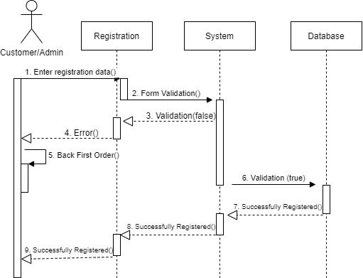

* The **User** initiates the registration of a complaint.
* The **System** calls the createComplaint() method.
* The **Complaint** object is created and saved in the **Database**.
* The **System** confirms the successful registration back to the **User**.

# ACTIVITY DIAGRAM

An **Activity Diagram** represents the workflow of the system. It focuses on the activities and transitions that occur, showing the flow of control and how actions are triggered.

**Activity Diagram: Tracking a Complaint**

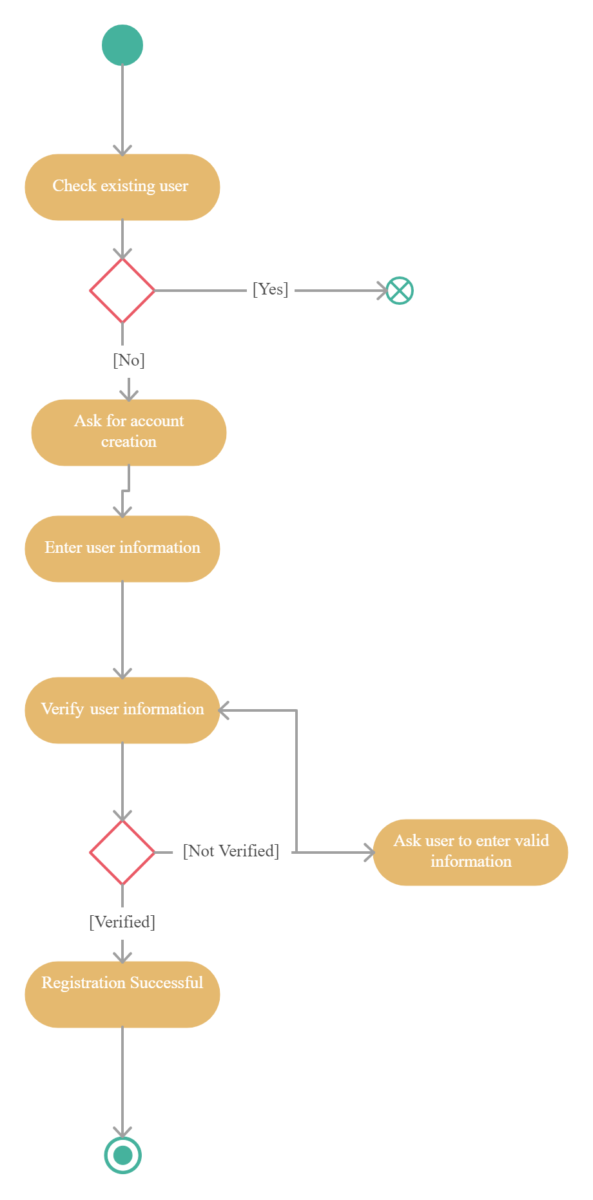

* The **User** logs in and enters the **Complaint ID**.
* The system checks the complaint's current status, and based on the status (resolved or under review), the user is shown the appropriate status and ends the process.

# STATE CHART DIAGRAM

A **State Chart Diagram** models the possible states of a particular object in the system and the events that trigger transitions between these states.

**State Chart Diagram: Complaint Lifecycle**

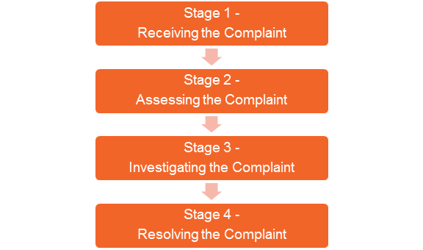

* The Complaint begins in the Registered state.
* It transitions to Under Review once an admin starts working on it.
* If resolved, it transitions to the Resolved state, and finally, it is Closed when the user acknowledges the resolution.

**CHAPTER 7**

**SYSTEM IMPLEMENTATION**

# PROPOSED SYSTEM

The **Proposed System** for the **Online Complaint Registration and Management System** aims to create an efficient, user-friendly platform that allows users to register complaints, track their status, and manage issues related to customer service, technical problems, billing, or other categories. The system will also provide administrative capabilities to handle complaints, assign them to appropriate teams, and generate reports.

## **System Overview**

The Online Complaint Registration and Management System will serve as a web-based application accessible by users and administrators through any modern web browser. It will consist of multiple modules to ensure smooth and effective complaint management. The system will allow users to submit complaints, track their status in real time, and interact with customer support, while administrators will have the ability to manage and resolve complaints, monitor progress, and generate reports for decision-making.

**Core Features of the Proposed System**

1. **User Registration and Authentication**:
   * Users will be able to create an account by providing personal information such as their name, contact details, and email address.
   * Secure login/logout functionality will be implemented with password encryption and an option to reset passwords.
2. **Complaint Registration**:
   * Users will be able to submit complaints with the necessary details, such as title, description, category (technical, billing, customer service), and priority.
   * Users will also be able to attach relevant files (images, screenshots, documents) to their complaints.
3. **Complaint Tracking**:
   * Registered users will have the ability to track the status of their complaints.
   * The system will provide real-time updates, such as when a complaint is under review, assigned to a team, or resolved.
4. **Admin Panel for Complaint Management**:
   * Admins will have a dashboard for managing and viewing complaints, including filtering by categories, status, and priority.
   * Admins will assign complaints to appropriate teams or individuals and monitor their resolution progress.
   * Admins can update complaint statuses and provide feedback or resolutions to users.
5. **Reporting and Analytics**:
   * Admins will be able to generate reports on various metrics, such as the number of complaints received, resolved, pending, and complaint trends over time.
   * Reports can be exported in multiple formats (e.g., CSV, PDF).
6. **User Feedback and Communication**:
   * Users can provide feedback on the resolution of their complaint, allowing for a continuous improvement process.
   * The system will include a messaging system for communication between users and admins, notifying users when their complaint status changes.
7. **Notification System**:
   * Users will receive email or SMS notifications when there are updates on their complaints, including when the status changes (e.g., complaint resolved, under review).
   * Admins will also receive notifications for new complaints and pending actions.

**Architecture of the Proposed System**

The proposed system will follow a **three-tier architecture**:

1. **Presentation Layer (Front-End)**:
   * **Technologies Used**: HTML5, CSS3, JavaScript, ReactJS or Angular for dynamic and responsive interfaces.
   * This layer provides the user interface through which both users and admins interact with the system. It allows users to submit complaints, track their status, and communicate with support. Admins use it to view, assign, and resolve complaints.
2. **Business Logic Layer (Back-End)**:
   * **Technologies Used**: Node.js or Django (Python), Java for business logic and API endpoints.
   * This layer is responsible for processing the input received from users and admins, handling complaint data, authenticating users, sending notifications, and interacting with the database.
3. **Data Layer (Database)**:
   * **Technologies Used**: MySQL, PostgreSQL, or MongoDB (depending on the need for relational or NoSQL data).
   * The data layer stores information about users, complaints, and system activities. It handles the storage of complaints, status updates, and user details in an efficient and secure manner.

**Proposed System Modules**

1. **User Module**:
   * User registration and login.
   * Complaint submission (text, attachments).
   * Complaint tracking and viewing status updates.
   * Feedback submission.
2. **Admin Module**:
   * Admin login and dashboard.
   * Viewing, sorting, and filtering complaints.
   * Assigning complaints to the appropriate teams.
   * Updating the status of complaints.
   * Generating and exporting reports.
3. **Complaint Management Module**:
   * Submission and categorization of complaints (technical, customer service, etc.).
   * Complaint status management (e.g., Pending, Under Review, Resolved, Closed).
   * Communication system between users and admins.
4. **Notification and Reporting Module**:
   * Real-time notifications via email/SMS for users and admins.
   * Reporting system to generate trends, analytics, and resolution times.

**Technology Stack**

1. **Front-End**:
   * **HTML5**, **CSS3**, **JavaScript** (for building responsive web interfaces).
   * **ReactJS** or **Angular** for dynamic content rendering and single-page applications.
   * **Bootstrap** or **Material UI** for UI components.
2. **Back-End**:
   * **Node.js** (for JavaScript-based server-side logic) or **Django** (Python-based).
   * **Express.js** (for Node.js) or Django REST Framework (for building APIs).
3. **Database**:
   * **MySQL** or **PostgreSQL** for relational data storage.
   * **MongoDB** (if using a NoSQL solution).
4. **Authentication and Security**:
   * **JWT (JSON Web Tokens)** for user authentication and session management.
   * **bcrypt** for password hashing.
   * **SSL/TLS** for encrypted communication.
5. **Notifications**:
   * **Email** notifications using **NodeMailer** or a third-party service like **SendGrid**.
   * **SMS** notifications using services like **Twilio**.

**User Interface Design**

The system will feature a clean, modern, and user-friendly interface to ensure accessibility and ease of use. Key design elements will include:

* **Responsive Design**: The interface will adapt to different screen sizes, making it mobile-friendly for users to submit and track complaints from smartphones.
* **Simple Navigation**: Users will be able to easily navigate through the complaint registration, status tracking, and feedback sections.
* **Intuitive Dashboard**: The admin dashboard will provide a high-level overview of complaints, with quick access to complaint details and report generation.
* **Accessibility Features**: The design will adhere to accessibility standards, such as WCAG, to support users with disabilities.

**Security Considerations**

The proposed system will follow best practices for securing user data and preventing unauthorized access:

* **Password Hashing**: Passwords will be stored securely using hashing algorithms (e.g., bcrypt).
* **SSL Encryption**: All data transmitted between the client and server will be encrypted using SSL/TLS to ensure data confidentiality.
* **Role-Based Access Control (RBAC)**: The system will implement role-based access control, ensuring that only authorized users (e.g., admins) can access certain features like complaint management and reporting.

**Implementation Phases**

1. **Phase 1: Requirement Gathering & Analysis**
   * Define functional and non-functional requirements.
   * Gather detailed information from stakeholders regarding user roles, complaint categories, and reporting needs.
2. **Phase 2: System Design**
   * Design the system architecture, database schema, and user interfaces.
   * Create UML diagrams (use case diagrams, class diagrams, etc.) to visualize system behavior.
3. **Phase 3: Front-End Development**
   * Implement the user interface for complaint submission, status tracking, and user feedback.
   * Develop the admin dashboard and complaint management screens.
4. **Phase 4: Back-End Development**
   * Set up the server, database, and API endpoints.
   * Implement business logic for complaint submission, status management, and notifications.
5. **Phase 5: Integration & Testing**
   * Integrate the front-end and back-end components.
   * Conduct system testing to ensure all features work as intended, including functional and security testing.
6. **Phase 6: Deployment**
   * Deploy the system on a production server.
   * Ensure backup and disaster recovery procedures are in place.
7. **Phase 7: Maintenance and Updates**
   * Monitor system performance and fix bugs.
   * Regularly update the system to include new features and improvements.

# SOURCE CODE

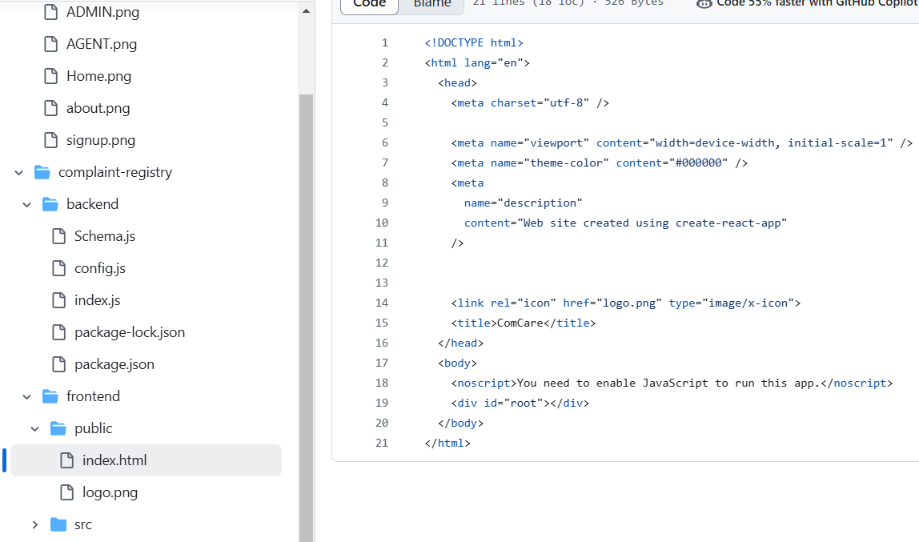

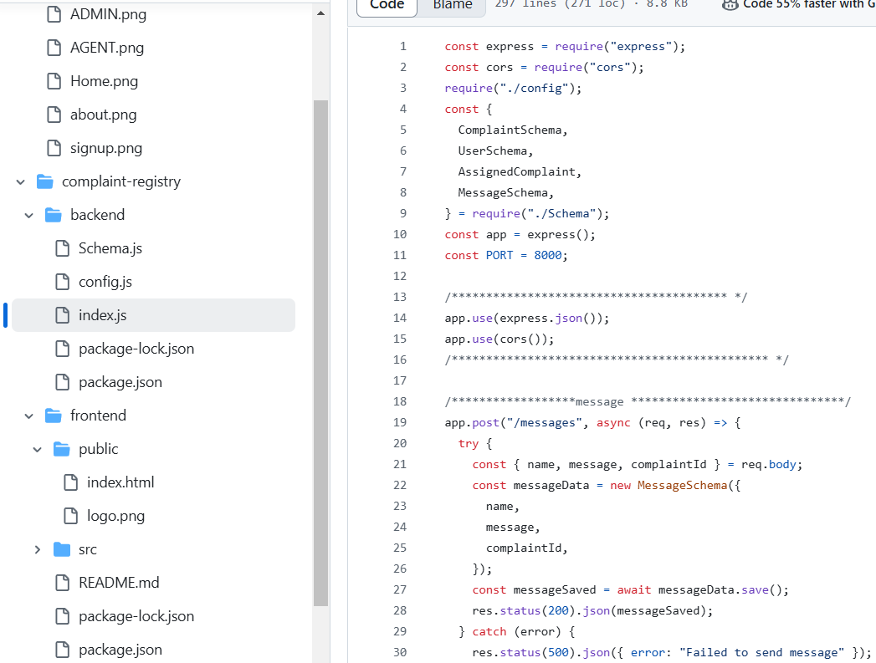

Code link: [complaint-registry](https://github.com/SELVAENGINER/MERN_STACK/tree/595903a8be547376f965a4ee5d5013c54941c22f/complaint-registry)

**CHAPTER 8**

**PROJECT DESIGN**

# Data Flow Diagram (DFD)

A **Data Flow Diagram (DFD)** provides a visual representation of the flow of information within a system. It shows how data is processed by the system, where it comes from, and where it goes. DFDs are typically created in layers, starting with a high-level **Level 0** diagram and then breaking it down into more detailed layers (**Level 1, Level 2**, etc.).

**Level 0 DFD (Context Diagram)**

The **Level 0 DFD** is the highest-level view of the system. It shows the system as a single process with inputs and outputs but does not detail the internal workings of the system. This diagram highlights the major external entities (actors) interacting with the system.

**Entities**:

* **User**: Submits complaints and tracks their status.
* **Admin**: Manages complaints and generates reports.
* **System Database**: Stores all data related to complaints, users, and administrative actions.

**Process**:

* **Online Complaint Registration and Management System**: The main system that interacts with users, admins, and the database.

**Explanation**:

* **User** submits complaints and tracks their status through the system.
* **Admin** manages complaints, assigns them, and generates reports.
* The **System Database** stores all relevant data (users, complaints, statuses, etc.) and communicates with the main system to handle requests.

**Level 1 DFD**

The **Level 1 DFD** provides more detail by breaking down the high-level process into sub-processes. In this case, we will break the system into processes such as **Complaint Registration**, **Complaint Management**, **User Management**, and **Report Generation**.

**Explanation**:

* **Complaint Registration**: The user submits a complaint. The complaint details are then saved to the database for future reference.
* **Complaint Management**: The admin views complaints, assigns them to relevant teams, and updates the status. The system updates the database when the complaint status changes (e.g., from "Under Review" to "Resolved").
* **User Management**: Users register their accounts, manage their profiles, and can track the status of their complaints.
* **Report Generation**: Admins generate reports based on complaint data, which can be exported or used for analysis.

**Level 2 DFD (Complaint Registration Process)**

To provide further granularity, we can break down the **Complaint Registration** process into more detail. This DFD shows the sequence of events from when the user submits a complaint to when it's stored in the database.

**Explanation**:

* The **User submits Complaint** step collects the complaint information from the user.
* The system **Validates Complaint Data** to ensure required fields are filled out correctly.
* **Attachments (if any)** are uploaded and processed along with the complaint.
* The system then **Submits the complaint to the database**, where it is stored.
* A **Confirmation email** is sent to the user to confirm the successful submission of their complaint.

# USER STORIES

**User Stories** are short, simple descriptions of a feature told from the perspective of the person who desires the new capability. They help the development team understand the requirements from the user's point of view.

**User Stories for Online Complaint Registration and Management System**

1. **User Registration**:
   * **As a user**, I want to register an account so that I can submit and track my complaints.
   * **Acceptance Criteria**:
     + The user can provide basic details (name, email, password).
     + The system sends an email confirmation after successful registration.
     + The user can reset their password if needed.
2. **Login and Authentication**:
   * **As a user**, I want to log in securely so that I can access my profile and complaints.
   * **Acceptance Criteria**:
     + The user enters their credentials (username/password) and is authenticated.
     + The user can log out of the system.
     + The system provides feedback if the login fails.
3. **Submit a Complaint**:
   * **As a user**, I want to submit a complaint with all the necessary details (title, description, attachments) so that my issue is recorded.
   * **Acceptance Criteria**:
     + The user can enter the complaint title, description, and category.
     + The user can upload attachments.
     + The system stores the complaint in the database and confirms submission.
4. **Track Complaint Status**:
   * **As a user**, I want to track the status of my complaint so that I know its progress.
   * **Acceptance Criteria**:
     + The user can view the status of their complaint (e.g., "Under Review", "Resolved").
     + The system updates the user when the status changes.
5. **Admin Complaint Management**:
   * **As an admin**, I want to view and manage complaints so that I can assign and resolve them.
   * **Acceptance Criteria**:
     + Admin can view all complaints, filter by status or category.
     + Admin can assign complaints to different teams or individuals.
     + Admin can update the complaint status and resolve the issue.
6. **Generate Reports**:
   * **As an admin**, I want to generate reports about complaints so that I can analyze trends and monitor performance.
   * **Acceptance Criteria**:
     + Admin can generate reports based on complaint categories, resolution times, and other metrics.
     + Admin can export reports to PDF or CSV formats.
7. **User Feedback**:
   * **As a user**, I want to provide feedback on the resolution of my complaint so that the system can improve.
   * **Acceptance Criteria**:
     + After a complaint is resolved, the user can submit a rating or feedback.
     + The system stores feedback and can be viewed by admins.

CHAPTER 9

ADVANTAGES AND DISADVANTAGES

# ADVANTAGES

1. **Improved Efficiency**:
   * The system streamlines the complaint submission and management process, reducing the need for manual intervention and paperwork. Automated features such as complaint tracking, status updates, and notifications save time for both users and administrators, leading to faster issue resolution.
2. **24/7 Accessibility**:
   * Since the system is web-based, users can register and track their complaints at any time, from anywhere, without the need for phone calls or physical visits. This provides a high level of convenience and accessibility for users, especially for those in different time zones or with busy schedules.
3. **Transparency and Accountability**:
   * The system allows users to track the status of their complaints in real-time, making the complaint process more transparent. Both users and admins can easily see where a complaint stands (e.g., "Under Review", "Resolved"), fostering accountability within the organization.
4. **Centralized Complaint Management**:
   * Complaints are stored in a centralized database, allowing administrators to view, manage, and prioritize complaints efficiently. The ability to assign complaints to appropriate teams and track their resolution ensures that no complaint goes unnoticed.
5. **Enhanced Communication**:
   * The system supports real-time notifications and email updates for both users and administrators, keeping everyone informed about the status of complaints. This reduces misunderstandings and ensures that users are kept up to date about the progress of their issues.
6. **Data Analytics and Reporting**:

* The system can generate reports on complaint trends, resolution times, and user satisfaction. These reports can be used by administrators to identify recurring issues, optimize processes, and improve the overall quality of service.

1. **Improved Customer Satisfaction**:

* With quicker complaint resolution and better communication, users are more likely to be satisfied with the service. The transparency and real-time updates also increase trust in the organization's ability to handle complaints.

# DISADVANTAGES

1. **Technical Issues and System Downtime**:
   * Like any digital system, the Online Complaint Registration and Management System is susceptible to technical issues such as server downtime, bugs, or network failures. These issues can temporarily prevent users from submitting complaints or administrators from managing them effectively.
2. **Dependency on Internet Access**:
   * Since the system is web-based, it requires a stable internet connection for both users and administrators. Users in areas with limited or unreliable internet access may face challenges in submitting complaints or tracking the status of their issues.
3. **Learning Curve for Users and Admins**:
   * Although the system is designed to be user-friendly, there may still be a learning curve for some users and administrators, particularly those who are not familiar with technology. Proper training and user support will be necessary to ensure smooth adoption.
4. **Data Security and Privacy Concerns**:
   * Handling sensitive user data such as contact information and complaint details raises security and privacy concerns. There is always the risk of data breaches, hacking attempts, or unauthorized access to personal information. Implementing strong encryption and security protocols is crucial to mitigate these risks.
5. **Limited Personal Interaction**:
   * The system relies heavily on digital communication, which may not be sufficient for all types of complaints, particularly those requiring personal interaction or sensitive discussions. Some users may prefer direct communication with customer service representatives rather than relying on a system interface.

**CHAPTER 10**

**CONCLUSION AND FUTURE ENHANCEMENT**

# CONCLUSION

The Online Complaint Registration and Management System is an essential tool designed to improve the efficiency of handling customer complaints and issues. This system allows users to submit complaints, track their progress, and communicate with administrators, while providing administrators with the tools needed to manage complaints, assign tasks, and generate performance reports.

The system’s primary goal is to streamline the complaint management process, enhance customer satisfaction, and ensure that complaints are resolved in a timely manner. By providing an organized and transparent platform for both users and administrators, it not only simplifies the process of tracking complaints but also improves accountability and responsiveness within organizations.

**Key benefits of the system include:**

* **User Empowerment:** Users can easily submit, track, and follow up on complaints without needing to call or visit the service canter.
* **Centralized Complaint Management:** Administrators can efficiently manage and assign complaints to appropriate teams, improving resolution times.
* **Data-Driven Insights:** Reports and analytics help administrators to monitor trends, measure performance, and improve service quality.
* **Enhanced Communication:** Real-time notifications and feedback mechanisms help keep both users and administrators informed about the status of complaints.

# FUTURE ENHANCEMENTS

While the proposed system is designed to meet the immediate needs of complaint registration and management, there are several potential enhancements that could further improve its functionality and user experience.

1. **Integration with Social Media and Third-Party Platforms:**
   * **Current Limitation:** The system relies on direct user submissions through its web interface.
   * **Future Enhancement:** By integrating the system with popular social media platforms (e.g., Twitter, Facebook) or other customer service channels (e.g., email, chatbots), users can directly lodge complaints via these channels. This could also include integrating with messaging platforms such as WhatsApp for real-time complaint resolution.
2. **AI-Based Complaint Categorization and Prioritization:**
   * **Current Limitation:** Complaint categorization and prioritization is done manually by the admin.
   * **Future Enhancement:** Implementing machine learning algorithms could automatically categorize and prioritize complaints based on keywords, user sentiment, or urgency. This would speed up the triaging process and ensure that critical issues are addressed promptly.
3. **Mobile Application:**
   * **Current Limitation:** The system is currently accessible via web browsers.
   * **Future Enhancement:** Developing a mobile app (iOS and Android) for both users and administrators would offer better accessibility. Users could submit complaints, track updates, and provide feedback on the go, while admins could manage complaints and receive notifications from their mobile devices.
4. **Real-Time Chat Support:**
   * **Current Limitation:** The system offers notifications and email updates but lacks real-time interaction between users and admins.
   * **Future Enhancement:** Adding live chat support within the system would allow users to get real-time assistance from customer support or administrators, improving the resolution time for urgent complaints and enhancing customer satisfaction.
5. **Multilingual Support:**
   * **Current Limitation:** The system might only support one language, which could limit accessibility for users who speak different languages.
   * **Future Enhancement:** Adding multilingual support would help users from different regions and backgrounds to file complaints in their preferred language, expanding the reach of the system to a more diverse user base.

**CHAPTER 11**

**APPENDIX SCREENSHOT**

**ADMIN PAGE:**

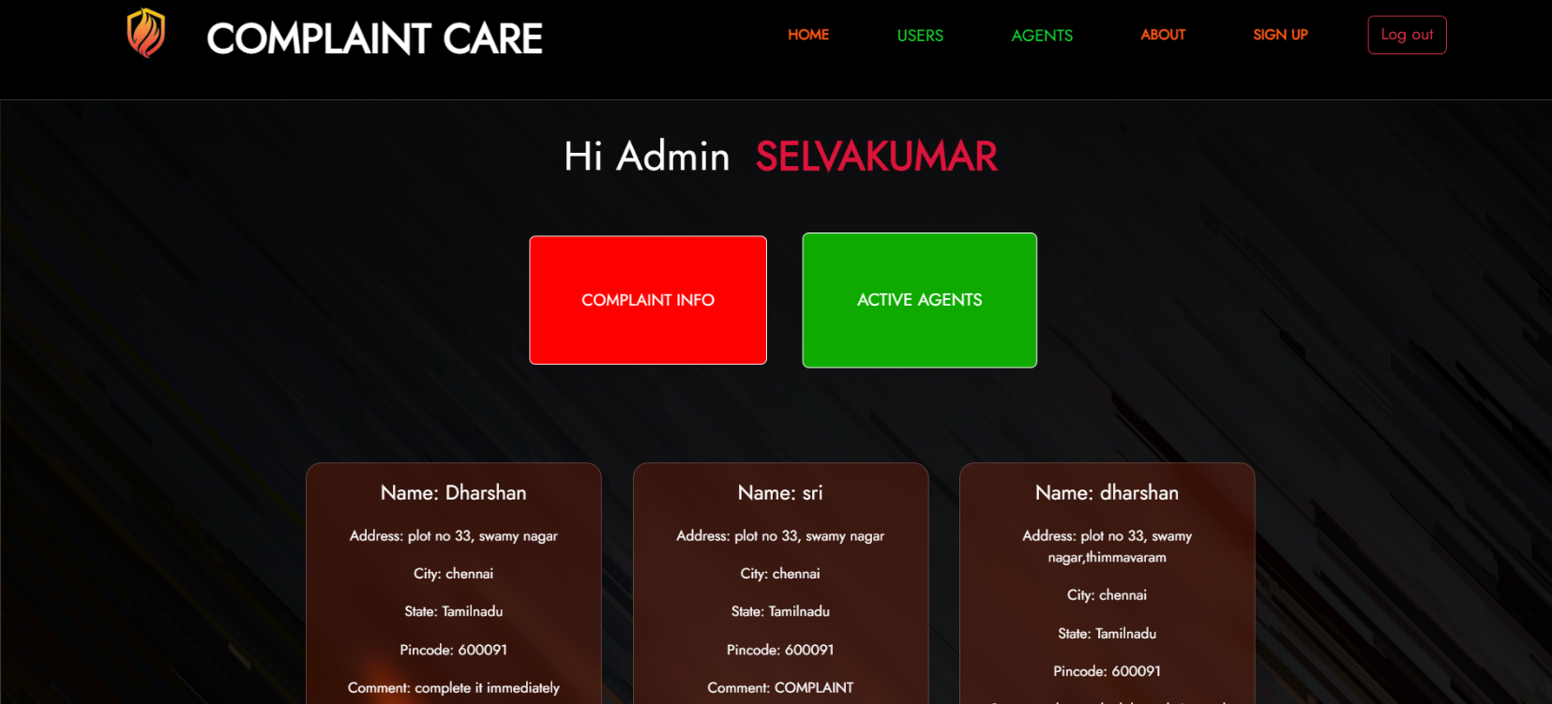

**HOME PAGE:**

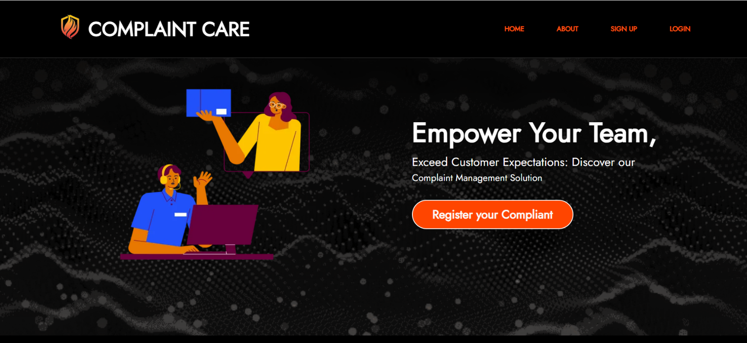

**SIGNUP PAGE:**

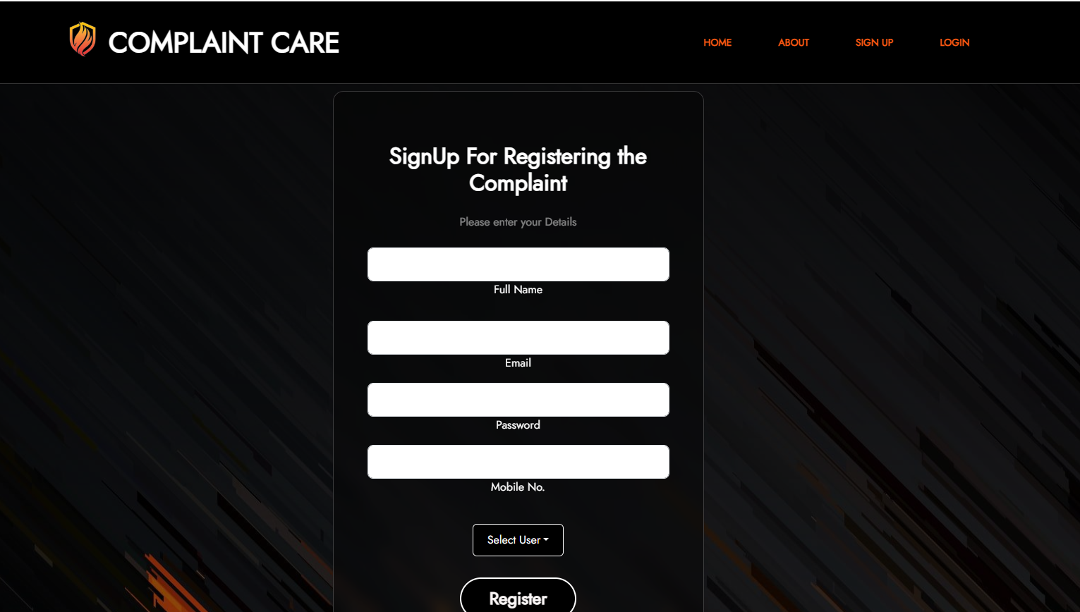

**ABOUT PAGE:**

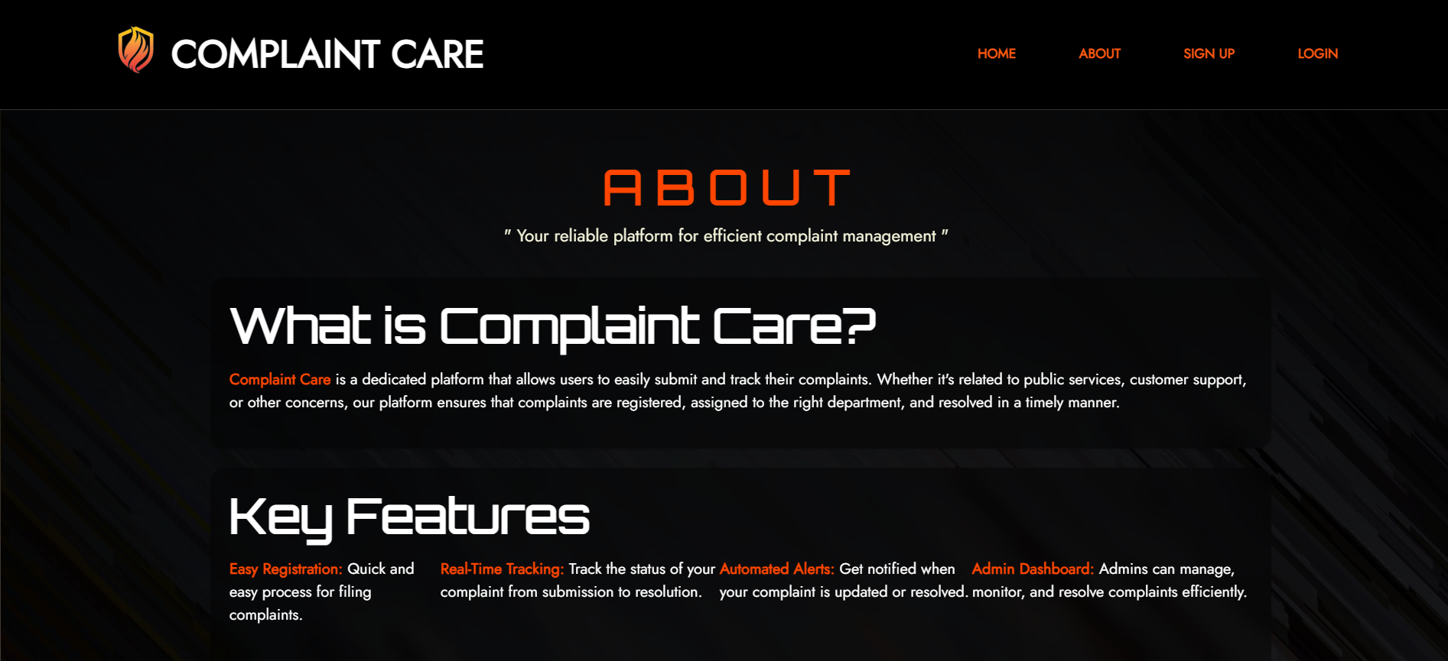

**ADMIN PAGE :**

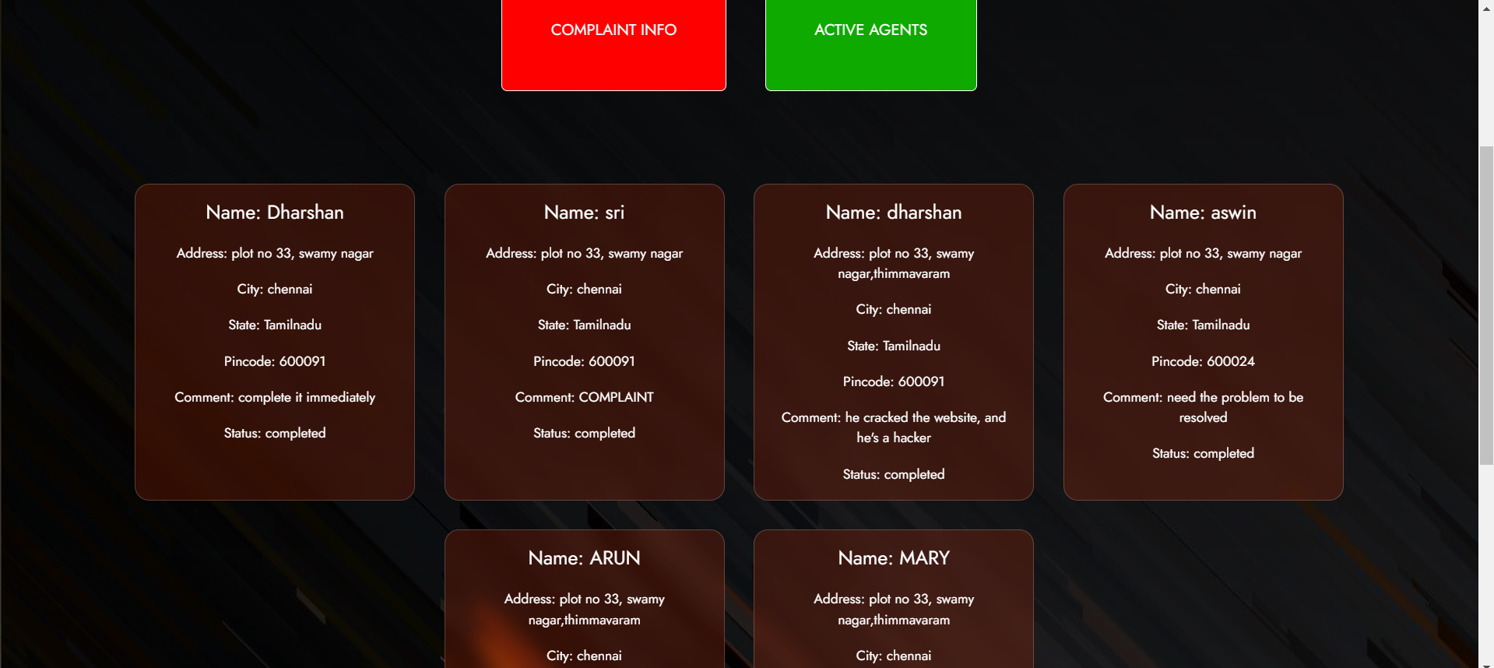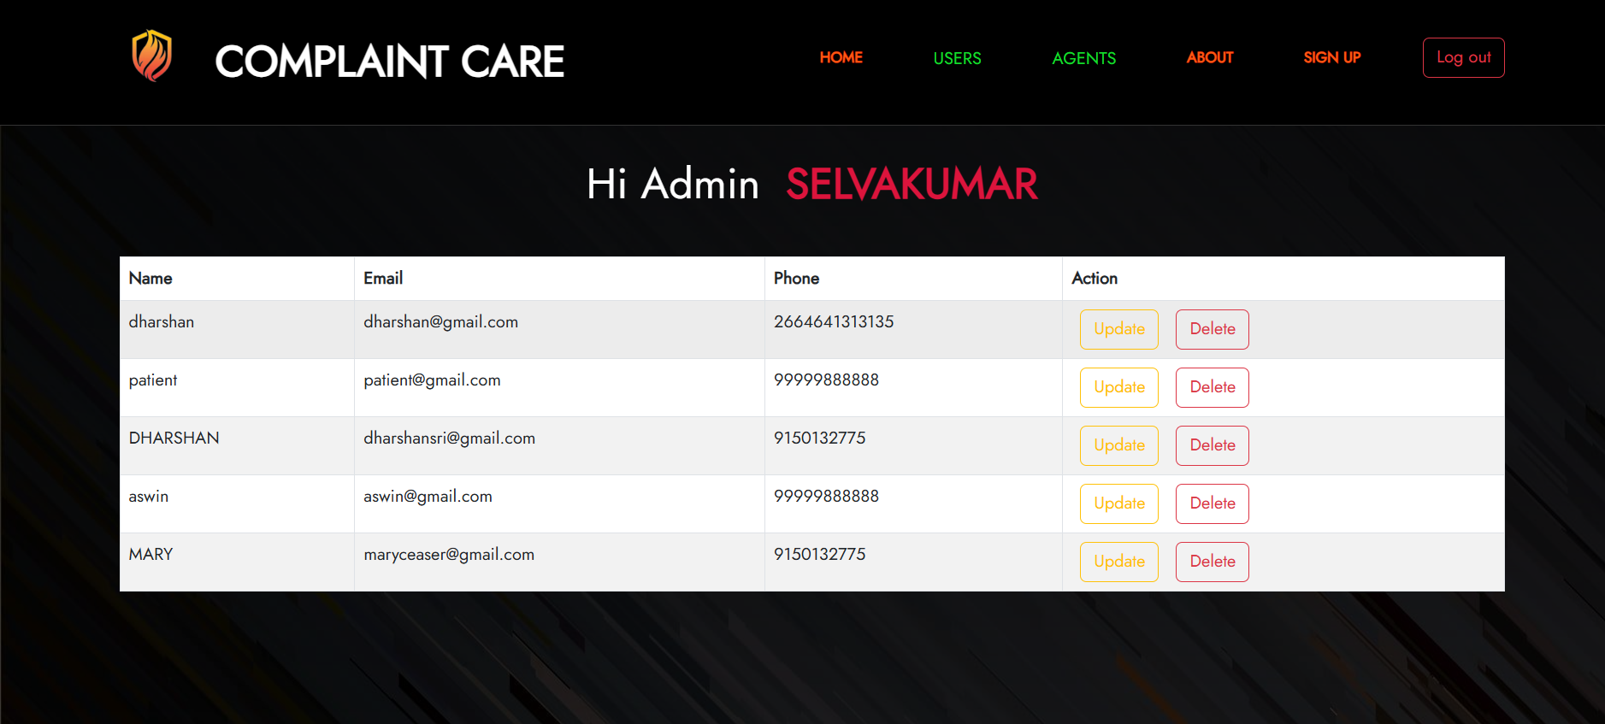

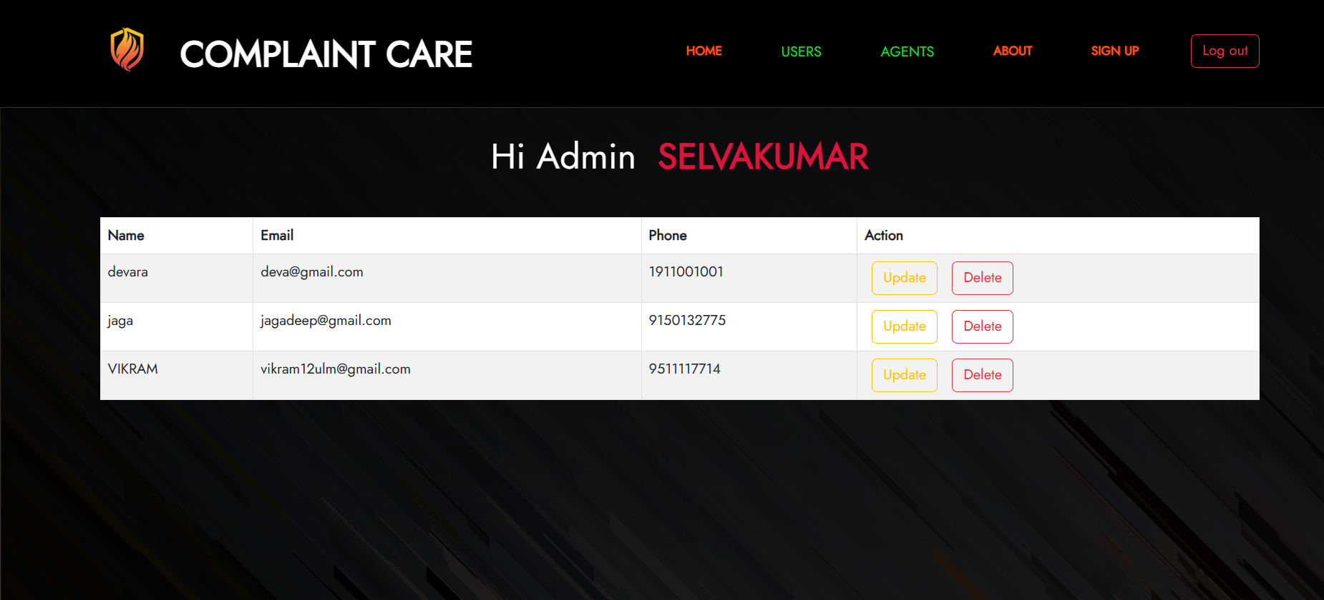

**USER PAGE :**

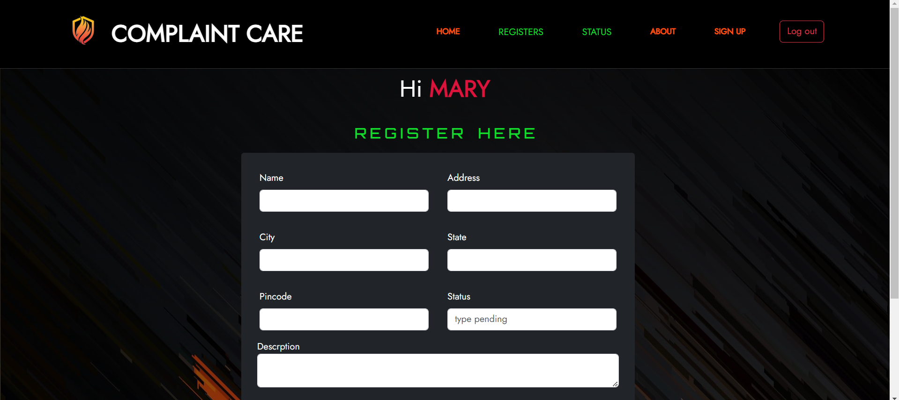

**AGENT PAGE :**

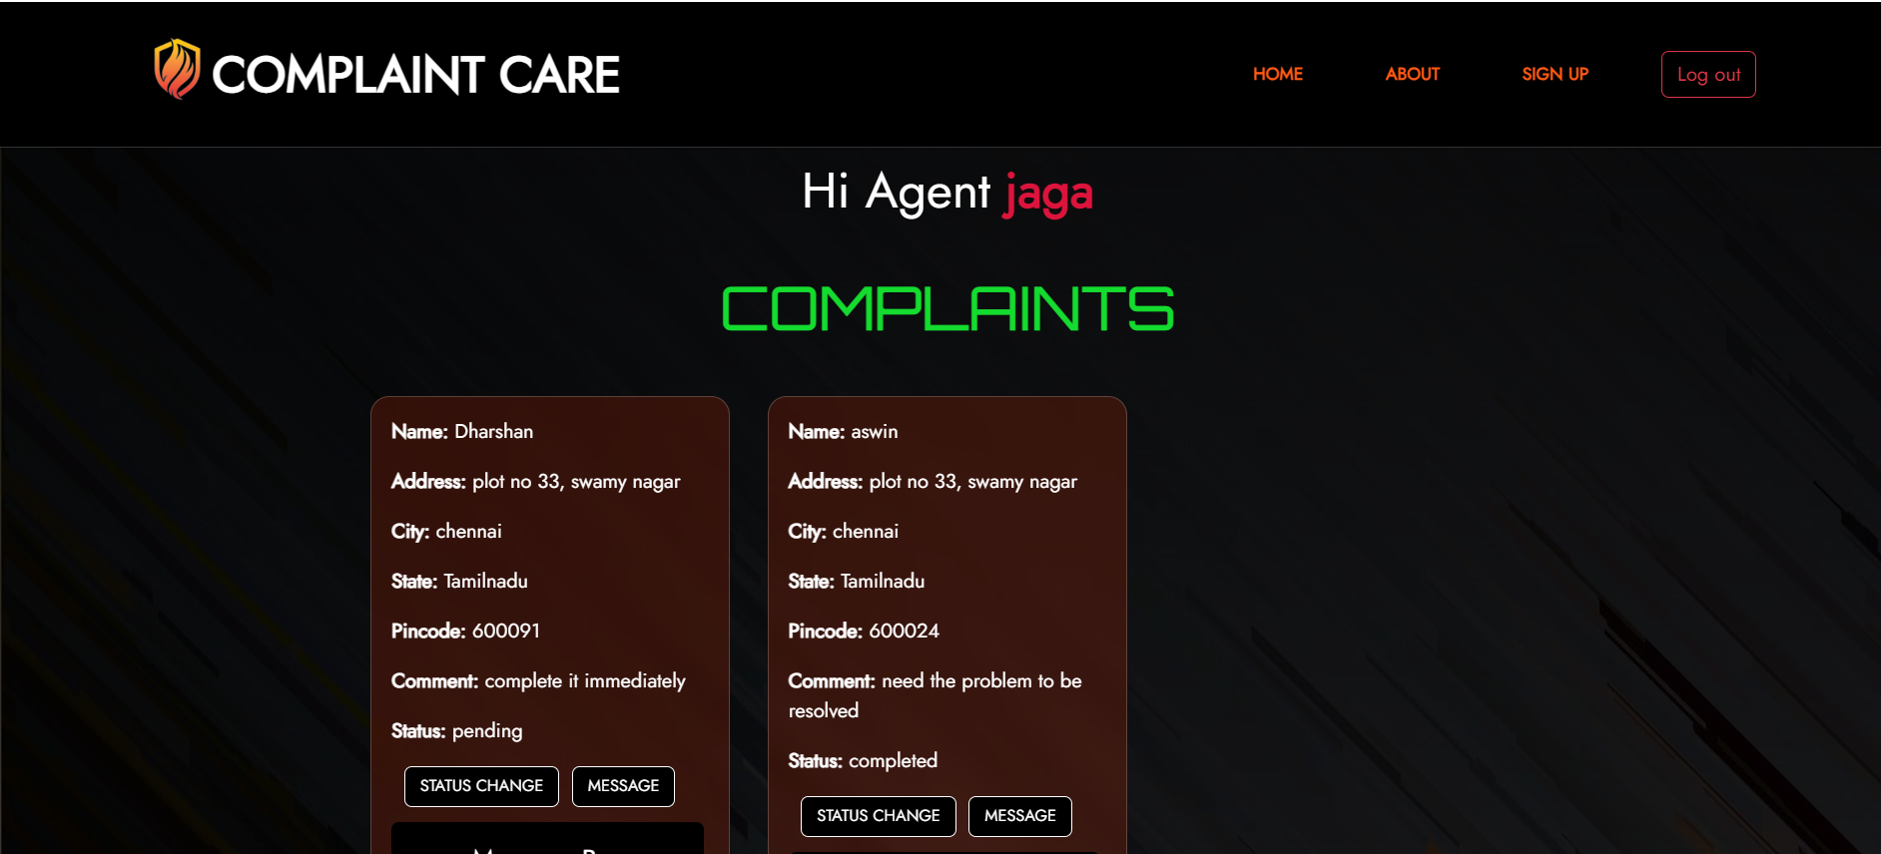

**DEMO-VIDEO PAGE:**

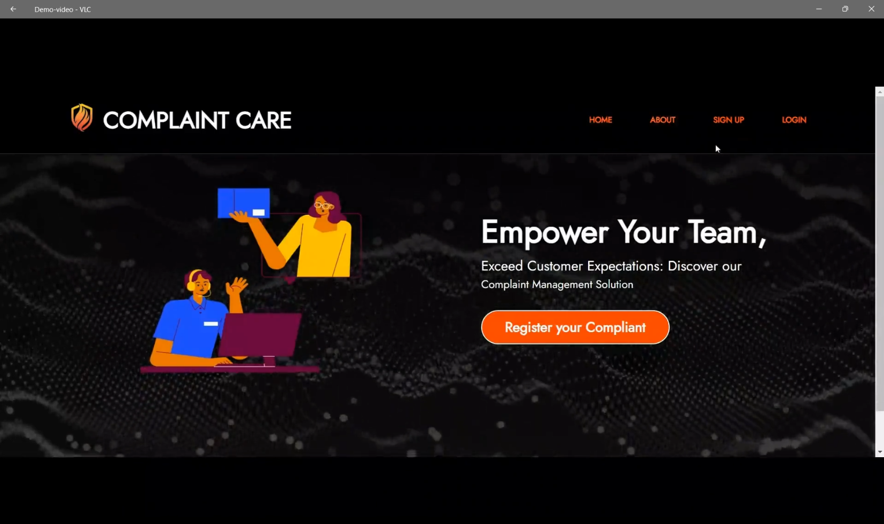

**Demo-video link:** [**Online_Complaint_Registration_and_Management_System_Demo-video.mp4**](https://github.com/SELVAENGINER/MERN_STACK/blob/595903a8be547376f965a4ee5d5013c54941c22f/Demo%20video/Demo-video.mp4)